Parasheet Sprint #3 Plan 2025-07-22

Goal:

Finish spreadsheet execution and editing.

Task Listing:

* User Stories
  + Execute a single cell (8 SP)
    - Task: Add operator precedence to parser
    - Task: Write Evaluator
    - Task: Fix literal tokenization
  + Execute Spreadsheet (2 SP)
    - Task: Expand execution to entire sheet
  + Edit Spreadsheet (2 SP)
    - Task: Add edit mode to parasheet-editor
  + Edit Cell in Text Editor (1 SP)
    - Task: Launch text editor with temporary file

Team Roles:  
Clara Ceerla - Product Owner

Elijah Hantman - Developer

Allex Smith - Developer

Quincy Strange - Developer

Eric Weng - Scrum Master

Initial task assignment:

Clara Ceerla - Add operator precedence to parser

Elijah Hantman - Add edit mode to parasheet-editor

Allex Smith -

Quincy Strange - Fix literal tokenization

Eric Weng -

Initial burnup chart:

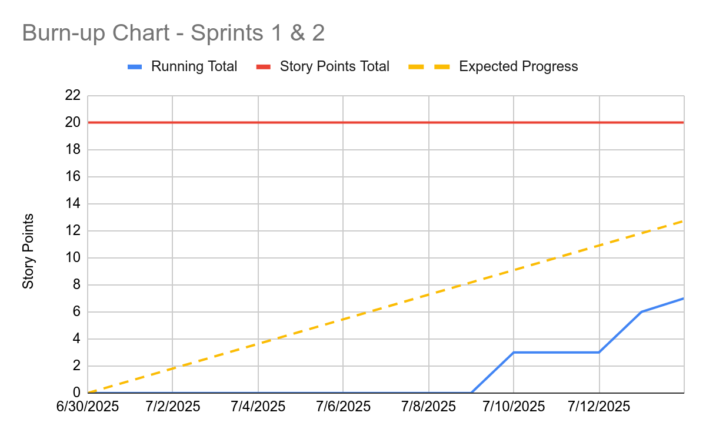

Initial scrum board:

| Available | In Progress | Under Review | Complete |
| --- | --- | --- | --- |
| Write Evaluator  Expand execution to entire sheet  Launch text editor with temporary file | Add operator precedence to parser (Clara)  Add edit mode to parasheet-editor (Elijah)  Fix literal tokenization (Quincy) |  |  |

Scrum times:

5:15 PM Wednesday

1:20 PM Friday